EEE211 The Design of an Operational Amplifier using PSpice

Introduction:
Doing this assignment, we design and simulate an operational amplifier circuit. In first part, you analyse three basic circuits. Integrating these circuits will be the next part.

This assignment is intended to reinforce lecture material in module EEE211 and reference to the relevant lecture notes is strongly advised.

Assessment:
You will need to submit your answers to a number of tabulated. The table reproduced in this script is for reference only. Your submission must be made electronically using the copy of the table that is available from ICE. The deadline for submission is one week after the laboratory. (See ICE page for the time of submission deadline)

Description:
The amplifier can be constructed from four basic circuits and simulated using library models located in the EVAL library for the following devices:-

Q2N2222 npn transistor
Q2N2907 pnp transistor

Part 1

Before commencing with the design, you should obtain a set of output characteristics for each of the two types of transistor to be used. Set up a circuit in PSPICE to achieve this (details can be found in the Appendix). Obtain the characteristics over the collector current range 0 – 5mA and collector-emitter voltage range 0 - 20 volts. From these characteristics, determine the Early voltage for each transistor.

Answer question 1 now.

- The common emitter amplifier

This is the first circuit that you should simulate. The basic circuit is shown in fig 1.

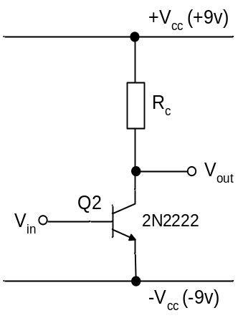
+9v
-9v
I_{BQ}
v_{in}
v_{S}

Fig 1 The common emitter amplifier circuit

The circuit should be supplied by a +9 to -9 volts split power supply that is balanced about ground as shown. Choose an initial value of (say) 1kΩ for the collector resistor R_{C}. The DC base bias current I_{BQ} should be supplied from a DC current source and its value chosen to ensure that the quiescent collector voltage is at zero volts. (To find the bias needed for this condition, sweep the value of I_{BQ} and measure the corresponding range of V_{out}).

Establish the appropriate DC bias condition first and then couple an ac voltage signal to the base via a coupling capacitor (say 0.1uF) so that the DC bias condition is not affected. Use a transient analysis to determine the voltage gain A_{v} = v_{out}/v_{in} , noting that because the input voltage is being measured at the transistor base terminal, the volt drop across the coupling capacitor is not relevant to the calculation. However, it will be convenient to avoid a significant volt drop across the coupling capacitor so you should choose a signal frequency that ensures that the impedance of the capacitor is negligible compared to the input resistance of the transistor.

It can be shown that the maximum voltage gain that can be obtained from the circuit shown is:-

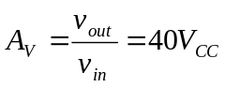 Eqn 1

In this example, V_{CC} is 9v, so the theoretical maximum voltage gain from this circuit is 360.

Repeat the measurement of the voltage gain for two further values of R_{C}. Ensure that in each case, the transistor bias I_{BQ} is adjusted to maintain the DC collector voltage at zero volts.

Now calculate the theoretical voltage gain taking into account the output resistance of the transistor.

Answer questions 2, 3 and 4 now.

2. The current mirror circuit

A popular circuit that provides an approximation to a constant current source is the ‘current mirror’. A pnp version of the basic circuit is shown in fig 2. Assuming that the supplies are fixed at +9 and -9 volts, the current in the collector of Q3 is determined by the resistor R2.

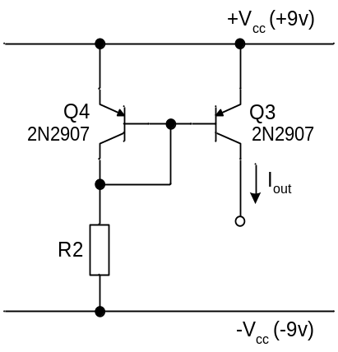

Fig. 2 – A pnp current mirror circuit.

Simulate the circuit and verify that the circuit operates as a constant current source (approximately). Determine its output resistance and lower voltage limit over which it may be considered to approximate to a constant current source.

[Hint: To do this, connect a voltage source to the collector of Q3 and perform a D.C. analysis in which that voltage source is swept from -9V to 9V. You can then plot I_{C}(Q3) as a function of output voltage to determine the effective output resistance of the circuit and its voltage limitation.]

Answer question 5 now

The voltage gain of the common emitter circuit already simulated (Fig 1) can be increased above its maximum value of 40V_{CC} if R_{C} is replaced by a constant current source.

Using a combination of the circuits given in figs 1 and 2, design a circuit to give a voltage gain of at least 1000 with a voltage supply of +9V to -9V. Remember to keep the current drawn from the supply well within the limit given in the specification to allow some current to be drawn by the remaining circuits that are still to be designed in next lab session (total current drawn from power supply MUST be less than 5mA).

Measure the voltage gain A_{V} = v_{out}/v_{in} and the total current drawn from the supply, I_{CC}.

Answer questions 6 and 7 now

3 The emitter follower

The circuit of an emitter follower is given in Figure 3. Note the following key equations that relate to this circuit:-

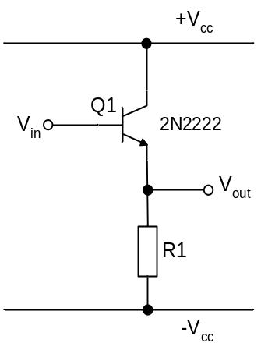

Fig. 3 – The emitter follower circuit.

Input impedance = 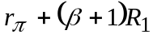
Output impedance = 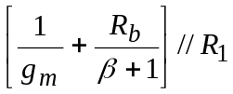
Where 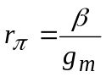
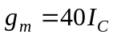

and R_{b} = total equivalent resistance ‘seen by’ the base terminal.

Using these equations, design an emitter follower stage that when added to the amplifier already designed, will give an output impedance that meets the specification (i.e. less than 1kΩ). Note that the emitter follower will represent a load to the voltage amplifier. Consider the effect of this on the voltage gain when you design your emitter follower. Also remember to keep the total current drawn from the supply well below the upper limit in the specification. (There are two further stages to be designed in Part 2 of this assignment to complete the full op-amp circuit).

Add the circuit to your previous design and measure the overall voltage gain, current drawn from the supply and the output resistance. [Hint: you can measure the output resistance by attaching a small ac voltage source to the output through a coupling capacitor (so that the DC bias of the circuit is not disturbed) and measuring the ac current.]

Answer questions 8 and 9 now
EEE211

PSpice experiment – Part 1
Design of Basic Transistor Amplifiers

QUESTION FORM

NAME: STUDENT ID:

…………………………………… ……………………………………

Question | Answer | For use by the marker
- Enter the Early voltages you have obtained for the transistors:  - Q2N2222  - Q2N2907. | a)  b)
2) Derive Eqn. 1 and explain the validity of it.
3) Give the three values of R_{C} that you used and the corresponding measured and theoretical values for the circuit voltage gains. | - R_{C} =  A_{Vmeasured} = A_{Vtheoretical} =  - R_{C} =  A_{Vmeasured} = A_{Vtheoretical} =  - R_{C} =  A_{Vmeasured} = A_{Vtheoretical} =
4) Consider R_{L} to –Vcc same of R_{C}. Repeat for A_{I.} | - R_{C} =  A_{Imeasured} = A_{Itheoretical} =  - R_{C} =  A_{Imeasured} = A_{Itheoretical} =  - R_{C} =  A_{Imeasured} = A_{Itheoretical} =
5) Give the measured output resistance and voltage limits of the circuit.  How are these values related to the transistor characteristics? | R_{out} = V_{lower limit} =
6) Copy your circuit in which current mirror acting as the collector load of the common emitter stage.

7) Enter the values you have obtained for the voltage gain, A_{V} and the current drawn from the voltage supply, I_{CC}. | A_{V} =  I_{CC} =
8) Copy your circuit here.
9) Enter the values for the voltage gain A_{V}, I_{CC} and the output resistance R_{O} | A_{V} =  I_{CC} =  R_{O} =

Appendix

Transistor Output Characteristics
To obtain a plot of the output characteristics of the 2N2222 transistor i.e. I_{C} vs V_{CE} (0 to 20 V insteps of 0.5V) for a range of I_{B} (0 to 40μA in steps of 4μA). First, input the circuit schematic below. To obtain the family of characteristics in one simulation, pull down the ‘Analysis’ window, select ‘Setup..’ check the ‘DC sweep’ option and input the variable as ‘Vce’ with the desired range. Use the ‘Nested sweep’ option to set the base current steps, I_{B} . Thus for each value of I_{B} (0, 4, 8.....40 μA), V_{CE} is swept from 0 to 20 V.

Calculate the d.c. current gain, β (also known as h_{FE}) at I_{C} ~ 2 mA. Estimate also the a.c. (small signal) current gain, β_{o} (also known as h_{fe}) at the same current. In this exercise we have assumed β ≈ β_{o} throughout.

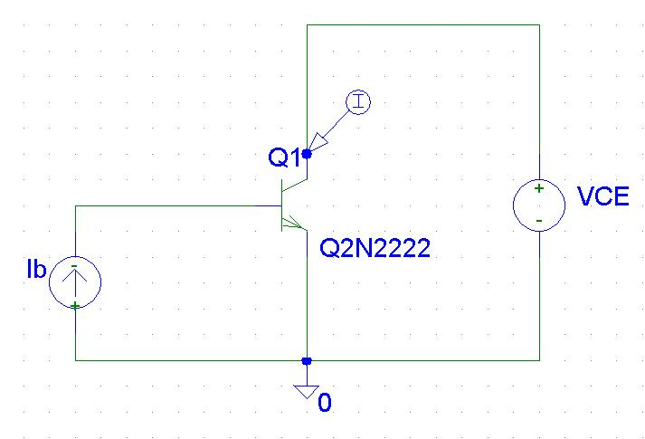

EEE211 LAB DOCUMENTS ARE PROVIED BY UoL COPYRIGHT REVERSED.
Tom Dowrick/S Hall/K Nuttall

